CS 255 System Design

UML Diagrams

UML Use Case Diagram
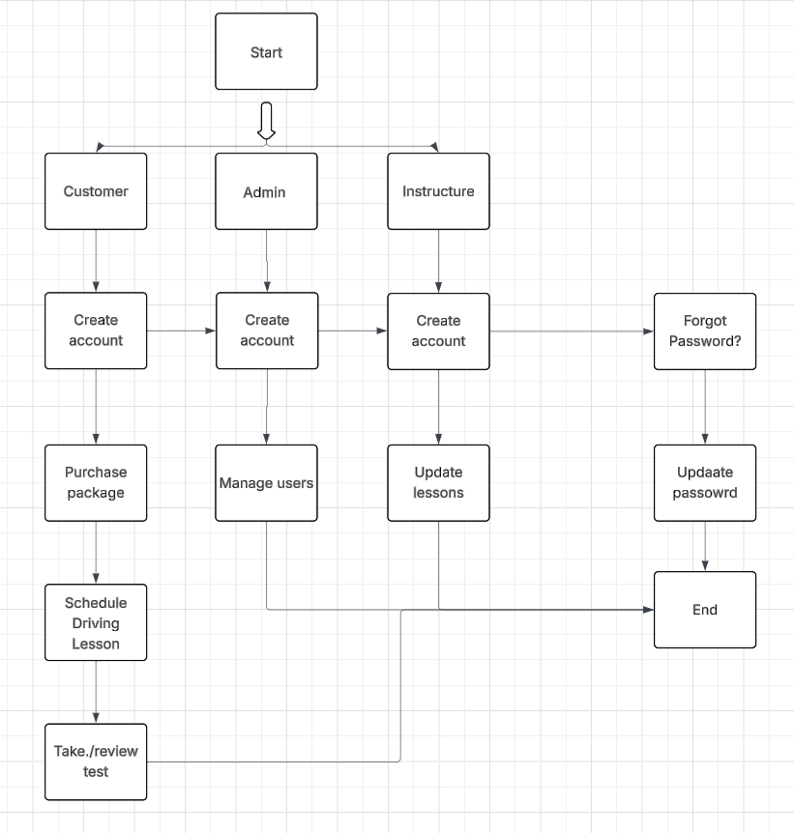

UML Activity Diagrams
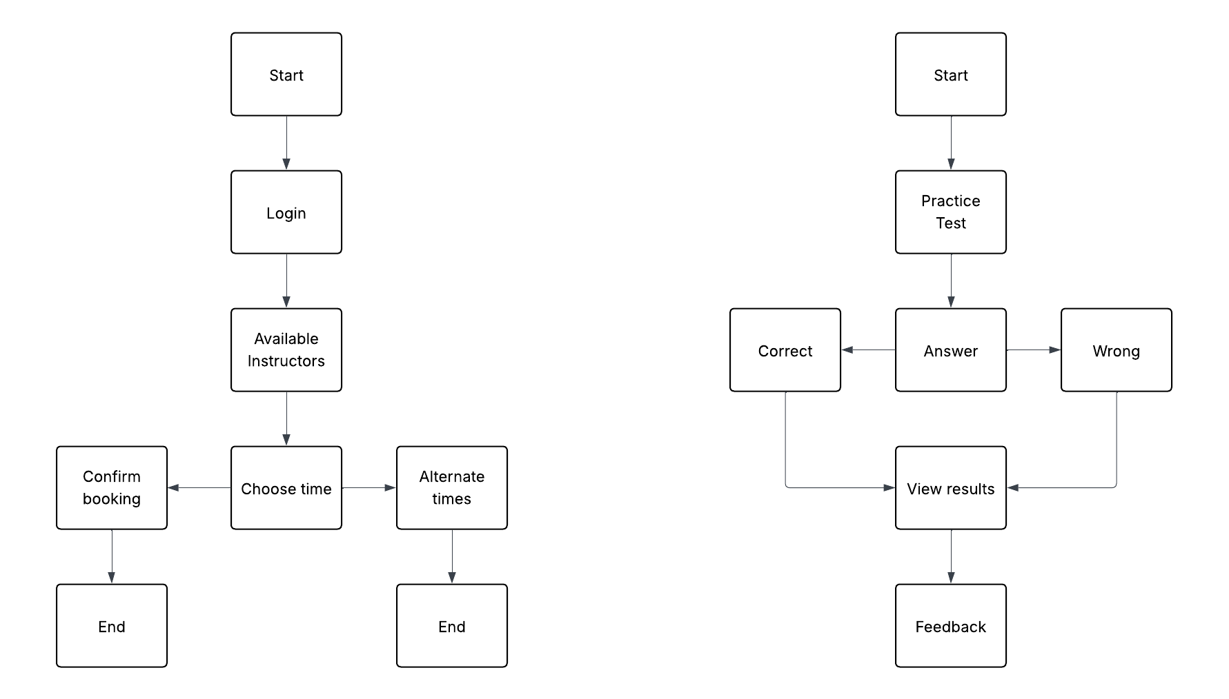

Signing up Taking practice test

UML Sequence Diagram
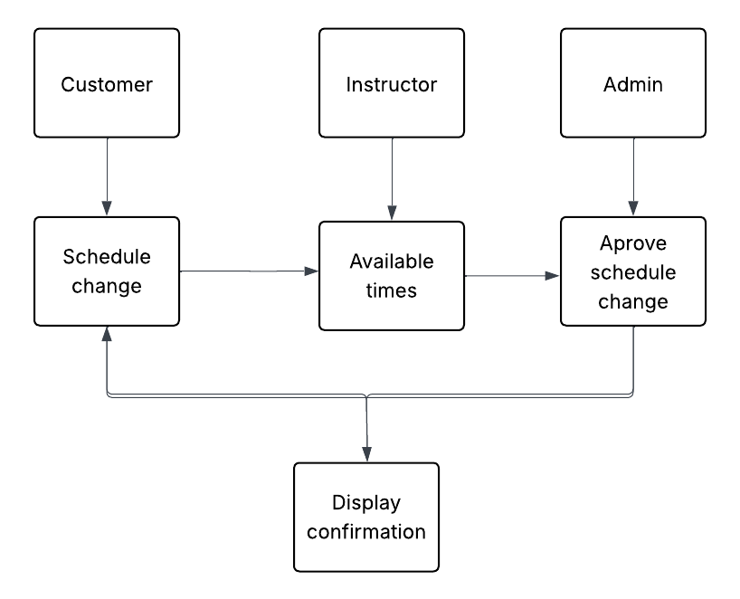

Schedule Change

UML Class Diagram
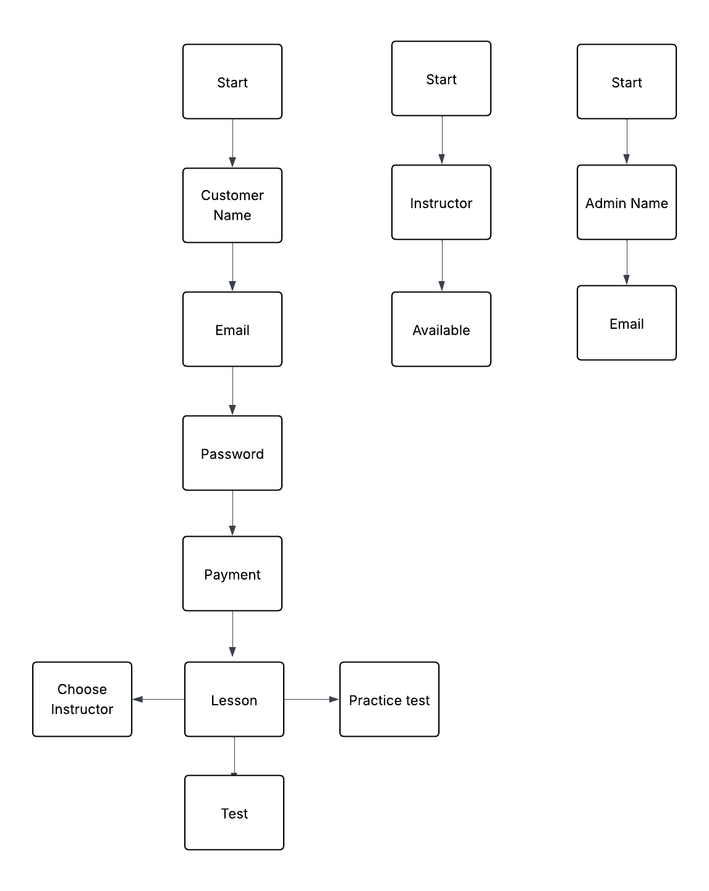

Technical Requirements
[The hardware requirements are reliable internet, so computers, tablets and smartphones can connect to the DriverPass system. By doing so the web browser can connect to the database server to save data of schedules, test results, applications etc. I believe using My SQL or SQL server would be a great software to use because with my experience with database I have had a positive experience. There are several different requirements, but I believe the most important is the security requirement. The security is to protect the user’s personal data. Also, different roles should have different access for example so a student is not able to cheat the instructor, and customer should have separate roles. Furthermore, different roles offer different capabilities. The customer should not have the same access to edit scheduling because it would not be beneficial for their success in the class.]

